0310120 陳家煒

Introduction to Machine Learning HW3

* Task：According to the class, we know what Decision Tree, K- nearest neighbor and naïve Bayes do. This time we use different classifiers/regressors to analyze two data sets (Iris.csv / forestfires.csv)
* Environment：OSX MAC、Ubuntu 16.04.3 LTS
* Language：Python 2.7.12, jupyter notebook
* Library：numpy, pandas, sklearn, seaborn, matplotlib

**Dataset 1 : Iris.csv**

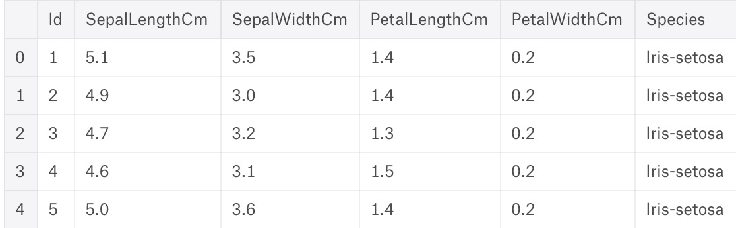

Simply imply sklearn Decision Tree, K-NN k=5, Gaussian Naïve Bayes …



According to the performance of accuracy, precision and recall (note that precision are both 100%), we can conclude that KNN > Naïve Bayes > Decision Tree in this case.

**Dataset 2 : forestfires.csv**

1. First convert the categorical type back to intuitive value:

* month - month of the year: jan to dec -> 1 to 12
* day - day of the week: mon to sun -> 1 to 7

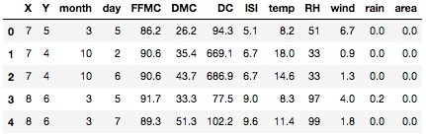

1. Explosion data analysis

* look into statistic info of dataframe

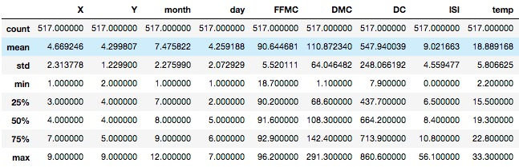

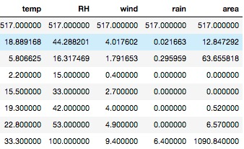

### Show the correlation with heat map

Notice that 'temp','DMC','X','month','DC','Y','FFMC','day','ISI','wind' are positive relative to the target "area"   
In contrast, 'RH','rain' are more irrelative to the target "area"



### Visualize distribution with density function

### Notice that feature temp acts like normal distribution in the dataset



Take a look at target ‘area’:

Notice that near 95% data gathering around 0



Apply log transformation y = log(1+x) 🡪 much more non-skew distribution



Since the original target ‘area’ distribution is too skew, so I decide to transfer area into log scale so that the regressor model can fit more concentrative data. i.e. area target from 0 – 1000 -> 0 – 3。

1. Data normalization:

Use sklearn MinMaxScaler

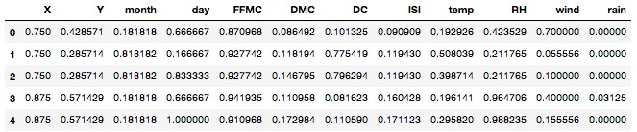

1. Model evulation:

* Mean Square Error

|  |
| --- |
| ((y_true - y_pred) ** 2).sum() |

* Variance score

|  |
| --- |
| The variance_score is defined as (1 - u/v), where u is the residual sum of squares ((y_true - y_pred) ** 2).sum() and v is the total sum of squares ((y_true - y_true.mean()) ** 2).sum(). The best possible score is 1.0 and it can be negative (because the model can be arbitrarily worse) |

* Decision Tree Regressor
  + Decision Tree mean squared error = 5596.96581573
  + Explained_variance_score: -0.274530239573



* KNN Regressor
  + KNeighborsRegressor mean squared error = 5431.07468267
  + Explained_variance_score: -0.245506833378



* Naïve Bayes approach: We define two different model

We define new class for target area: [0, 0-10, 10-100, 100-1000, 1000+] 6 different type



* Categorical features such as ['X','Y','month','day'] apply categorical model - MultinomialNB (with Laplace smooth)



* Continuous features such as ['FFMC','DMC', 'DC', 'ISI', 'temp','RH', 'wind', 'rain'] apply categorical model - GaussianNB (with Gaussian smooth)



* Mix categorical and continuous model

Concept of Naïve Bayes

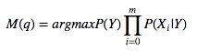

Implementation of Mixture Model



* Performance

Categorical: 45.51%

Continuous: 22.44%

Mix model: 23.72%

* Detail prediction of each model

|  |  |
| --- | --- |
| Categorical | Screen%20Shot%202017-12-20%20at%203.18.39%20PM.jpg |
| Continuous | Screen%20Shot%202017-12-20%20at%203.18.50%20PM.jpg |
| Mix model | Screen%20Shot%202017-12-20%20at%203.19.03%20PM.jpg |

It is clear that the result of Categorical model almost dominated by the most frequent tar-get 0, since probability base approach will lead to this kind of result especially when the data distribution is quite skew.

In the contrary, predictions of Gaussian model are much more distributed and strongly influence the prediction of mix model.

 

